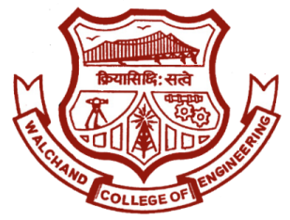

WALCHAND COLLEGE OF ENGINEERING, SANGLI

**ELESA**

**ELECTRONICS ENGINEERING STUDENTS’ ASSOCIATION**

Email: [walchand.elesa@gmail.com](mailto:walchand.elesa@gmail.com) Website: [www.elesa.in](http://www.elesa.in)

**Date:- 09/4/2018**

**SECRETARIAL REPORT ON**

**Excellence**

This year ELESA organised Excellence specially for Final year electronics engineering student. The motto behind organizing this event was to make student especially for final year students familiar with Campus recruitment process. Throughout the year ELESA organises Aptitude session , Technical session and various activities which help students to get ready for campus recruitment process. The design of event was done in such way that it will resemble to actual hiring process.

On first day i.e. on 9th April 2018 the presentation of company was done and following to it the offline aptitude test was conducted. 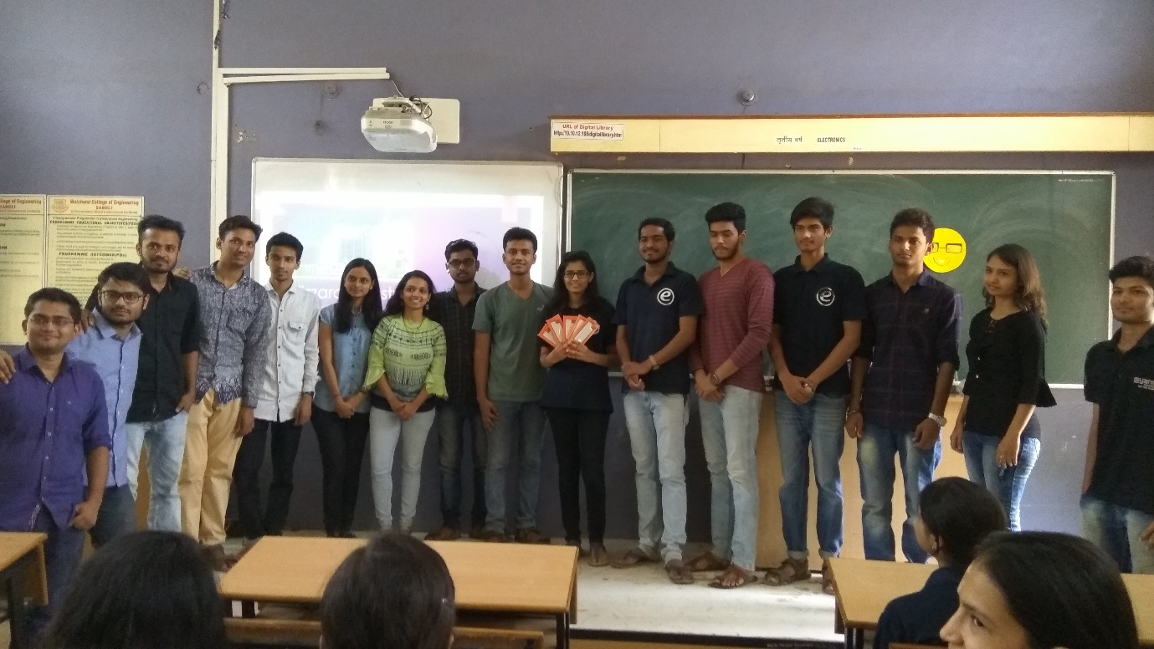

On Second day i.e. on 10th April 2018 Group discussion of candidates was taken In which brainstorming topic were given to students and their thinking process and behaviour was checked. After GD the Technical interviews of candidates begun. Since this was mock recruitment process no shortlisting was done in order to let candidate go from every stage of hiring process. Technical interviews continued on Third day as well

On fourth day i.e. on 12th April 2018 the HR interviews took place. After every interviews students were given feedback so that they can excel in their future interviews. 23 students from Third year 15 students from Second year and 12 students from First year Electronics were participated in this events.

Mr. Mahadev Mishal

Secretary,

ELESA